While she sleeps webstore

NEA Project

4205

Richard Burney

Contents

Analysis 2

The Problem Definition 2

Background research 3

Description of Current System: 3

Identification of End Users/Players 4

Objectives 5

Design 7

Core Functions 7

Algorithms 8

User Interface 9

Framework 9

Security and Validation 9

Flow Charts 10

Entity Relationship Diagram 11

Data Flow 12

Testing 13

Test Strategy 13

Testing video 15

Test Table 16

Evaluation 17

# Analysis

## The Problem Definition

* A website is a series of pages linked together for the ease of use for the user. A website has become the best way of marketing, sharing information, shopping and much, much more. Websites are used by millions of different companies for all of their different needs. Whether it is selling goods, advertising pubs or a way to tell your employees their shift times for the following weeks, websites are used. For example, a website could be used for a small, freelancing start-up, to help broaden their client base by using ads leading directly to their website (so the client can see what the company is cable able of) rather than just an email or phone number, meaning there is no way to see the companies’ previous work. Websites can also be useful for accessing databases on the go, such as inventory, so managers can find out what they need to stock up on from anywhere in the world.
* A website can be the single, most important tool for a band, as it is a way to get their music out there, list the concerts they are playing and allow their fans to buy their merchandise.
* A bad website can lead to fans being misinformed or even losing their orders. This emphasis on websites, will only increase as the world becomes even more digital; to be successful without a website is now harder than ever. The ease of having a website to the end user is astronomical, being able to access it anywhere, on any device, every day of the year.

## Background research

* Most dedicated band websites have a few similar parts to their websites; tours, store, a page about their music and page about themselves. Also, some of these bands have different store for different parts of the world, ie. Us and eu. In addition to this, many store websites have a most popular bought items page that has the most frequently bought items on it. Specifically, the While She Sleeps website is mainly used as a store and the band, themselves, is the secondary function of the website. Only 3 out the 10 tabs of the top of the page are not part of the store. These websites also provide a way for people that would have to travel far to see a show to be able to buy merchandise as they would not be able to go to a show to buy some there.
* Other shop websites have similar features, such as saving the users cart when they go offline, saving the users address and payment details. These websites also have the homepage where the most popular items are shown, to increase the chance of the user buying from the store.

## Description of Current System:

* + There are quite a few websites that are dedicated to website building. These have templates that you can follow to create your website also these websites can sell domain names. These websites require monthly payments rather than a big one-time payment, like a regular website creator would, but on the plus side nothing needs to be update manually by the user as the websites does all of that for you. However, the problem with these website builders is that you do now have the freedom to do what you want with your website, or what you need to. These builders might not have the needs you require for your website. Also, if you pay someone to build you a website, it is a one-time payment so recurring payments cannot come back to haunt you.
  + There are many websites with a store selling ‘While She Sleeps’ merchandise, including their official website. But the information of the band can only be found on Wikipidea, which can be edited by anyone so it is not completely reliable. In all of these stores, it is difficult to tell what is official and what is not. Also the profits of the merchandise would not go to the band but a third party company that has no relation to the band.

## Identification of End Users/Players

* + The end use would be a fan of the band looking to find out more info on the band or looking to buy some merchandise of the band. A user might be looking into what shows the band are playing next, or what other music they have made. However, the main purpose of the website is to sell their merchandise, and the user would use this website to look through all that the band is offering and decide what they would like to buy. The user could also access the website on their phone, making it even easier to use the website on the move as everyone has a phone so anyone can access the website at all times, from anywhere. The age range of the customers would be late teen to adult as this would be the age range that listens to the band’s music. Also the band and management staff would use the website to add to the store and to the shows list. They would also be able to see what items from the store are running low on stock.

## Objectives

* + Have a functioning profile system that can be updated by the user
  + Have a store that can be used by the user to buy merchandise
  + Have the store pull the address from the user’s profile but asks whether it is right
  + Have a most popular page on the store that is automatically updated with the items that have been bought the most
  + Have an easily updatable shows page that takes off a show when it has been finished automatically
  + Have the shows page be updated by an admin user that can access other parts of the website
  + Have tweets from their official twitter integrated into the website
  + Be able to pull items from the different categories into the cart
  + Have a clean UI that is easy to understand so people can easily navigate around the website
  + Have an admin page that can be used to manage the shows page, the store and orders.
  + Remember the cart for a specific user when the user closes the website or it is restarted
  + Let a user delete their account
  + Have the website show all necessary information on the band
  + Have a page to view previous orders with amount spent and items bought
  + Have a page that can show the ongoing orders and show how far along in its journey it is ie. Shipped, delivered or processing
  + Have levels of access granted to different people ie. Admin, Owner, regular user
  + Have a page where the owner can change the permissions of the other users
  + On the admin page let the admin add shows or edit shows
  + On the admin page let the admin add stock to existing items or add a new item to the store.
  + Allow an admin to put an item on sale
  + Allow an admin to see all the orders that aren’t delivered. And to be able to change the status of specific orders. When an order is changed to delivered, it will disappear from the table.
  + Have email notifications for shows that are coming in a specific area.

# Design

## Core Functions

* A place where fans of the band can come and find out what shows the band will be playing.
  + The website displays all of the future shows that the band is playing with the location, venue and the date of the show. Every time someone enters this page the website checks whether any of the shows is in the past, and if it is then it is deleted from the database and is not displayed. This is to make sure that there is no confusion for the users when deciding whether to attend a show or not.
* A place where fans can buy official band merchandise
  + The website has a page where all the band merchandise can be bought. There are also sub sections for each category such as men’s/women’s/outwear. From this page the user can also access their cart, which is saved even when the user is not logged in. When a user clicks on an item, a specific item page appears where images of the items are displayed with the stock of each size and the size. From this page a user can add a number of items to their cart and from their cart remove them again if needed. And if not, the user can checkout from here where they have to confirm their address and card details and then order said items.
* A portal for admins and owners
  + For admins, this is a place where an admin is able to view all of the items in the store and how profitable each item is. With also the total profitability of the website. One of the tabs is the orders page, here an admin can see all the orders made by users, also on this page an admin can update the order status. Next is the stock section of the admin page, here it shows all of the stock and here an admin can top up the stock of a specific item or add a new item to the store. The final part of the admin section is the shows page, where an admin can view all of the shows, add a new show or edit an existing show. For owners, they still have access to the admin section but also to the user access section, here an owner can see all the users register on the website and can change their access level from here.
* A profile page for all users
  + This is a page that ever use has. Here the user can see all of the data that the website stores. They can also edit their profile, delete their account or logout. There is also a link to the user’s order page.
* A place where users can view all their orders
  + Here every user can access their orders active or not and no matter how old. They are ordered by date. It shows the date, the items, the quantity and the cost of the orders.

## Algorithms

* The create user algorithm checks that you enter a username, email and password when creating your account. It also checks whether anybody else has used the same username or email and if they have it tells you to choose a different username/email. This data is then added to the User database and it means that the user can login whenever they choose. It also means that the user can easily update the information stored on them when needed. If they so choose, the user can also delete their account, which deletes the whole entry in the database but not their orders which are saved for statistical purposes.
* The email notifications algorithm allows the user to add a place where if show is happening, they get an email about it. Their user enters the place in which they would like the emails about, then the website stores this in the Email_not database along with the users ID. When a show is created, the website checks all of the entries on the Email_not database for a match, and if there is it pulls out the user’s email and sends them an email with the details of the show.
* The add to cart function allows the user to add a certain item to their shopping cart. This checks whether the same item is already in the cart but checking the stock_id and if it is, then it adds “1” to the quantity in the cart, if it is not in the cart, then it will add the item to the cart database along with the stock_id, item_id and user_id. The opposite of this the removing an item from the cart. This checks how many of the item is in the cart, if it is 2 or more, it just removes 1 from the quantity in the database. But if the quantity is 1, then it removes the item from the cart entirely.
* The add show and edit shows function just allows a user to add or edit data in the Concerts database. Basic but works as intended.
* The delete shows algorithm works by every time someone enters the shows page, it checks the current date and compares it to the date of the show and if the date of the show is in the past, it deletes the show from the database. It the date is in the future or the same as the current date, it is left alone.
* The add to store algorithm allows the user to add an item to the store but it checks whether there is already an item with the same ID and/or name. If there is then a new ID will be made, but if not, then the item is just added to the store and stock databases respectively.

## User Interface

* I have chosen to have a graphical interface for my website instead of a command-line interface as a command-line interface would not fit a website environment. On my website my main source of navigation will be a navigation bar at the top of the page which leads to the main pages of the website, such as the store, music and a profile page. I will also make it easy for users/admins to change aspects of what data the website stores ie. User data of Store item data. There is also a separate navigation bar for the store that have links to store specific pages such as men’s/women’s, but also has a link back to the main page of the website where all other aspects of the website can be accessed. In the admin tools section, which is accessible from the profile to applicable users, there is a secondary navbar which shows all of the sections of the admin tools. I thought this was necessary so it is easy to navigate for the user. In the admin/owner section, there is another navigation bar which is displayed under the first one. This gives links to all of the tools available to the user, I have done this so it is easy for an admin to navigate through these pages meaning they can have a higher workflow.

## Framework

* The website is built using python and Flask, this is because it has a straight forward layout meaning necessary files are neat and easy to read as there is not just random code all over the place. Also, python is capable of everything that I need, I do not need anything more complex for the tasks. Flask also complies with SQL very well and integrating databases into my website was easily achieved. Flask also allows for a dedicated layout page, which means my html files can be small and more concise as I only need the body in the file and edits in the head. The stylesheet I will be using is Bootstrap, this is because bootstrap is the most common stylesheet on the internet meaning it is very stable and will play nicely with all the most common browsers.

## Security and Validation

* All of the passwords are hashed when saved so the password text is not store anywhere in any database. This is so that even if the databases were hacked, passwords were not be leaked. Also the user’s credit card info is never stored and is deleted immediately after user, if this was going to be used in the real world, then I would implement PayPal as it is the most common, secure way of paying for things.
* All of the admin pages and owner pages are secured behind a user access level check. If no user is logged in, then the url will return a 404 error. If the user has an access level of 1, the url will return a 404 error. If the user has an access level of 2, then it will return the admin page and if the user has an access level of 3 it will return the admin page along with the owner tools.

## Flow Charts

Index

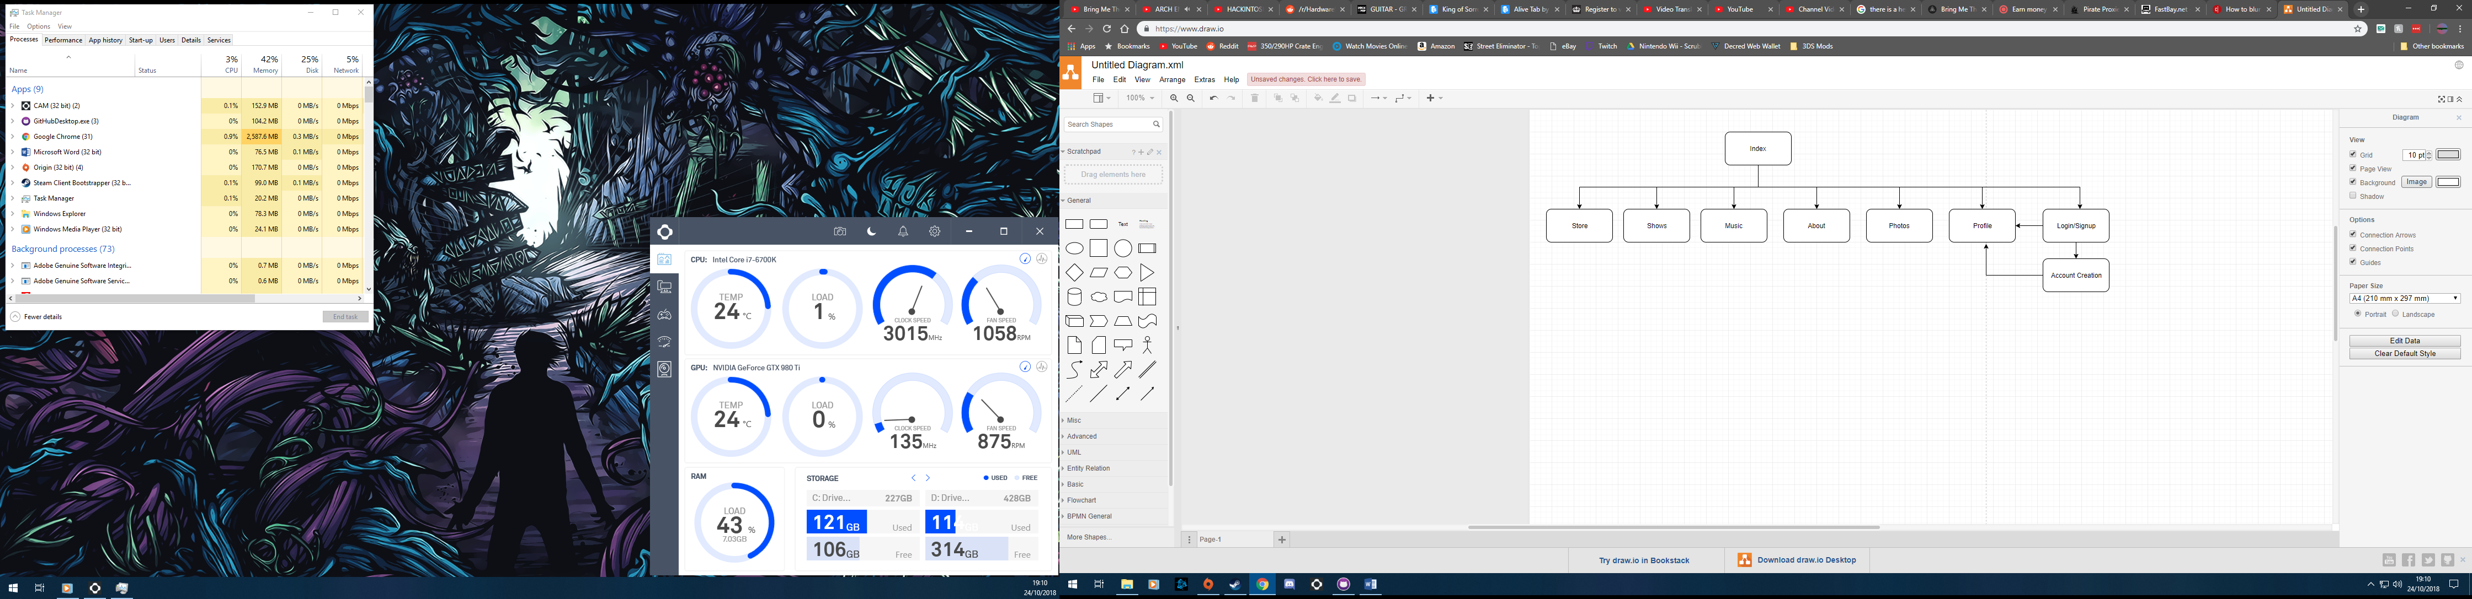

Store

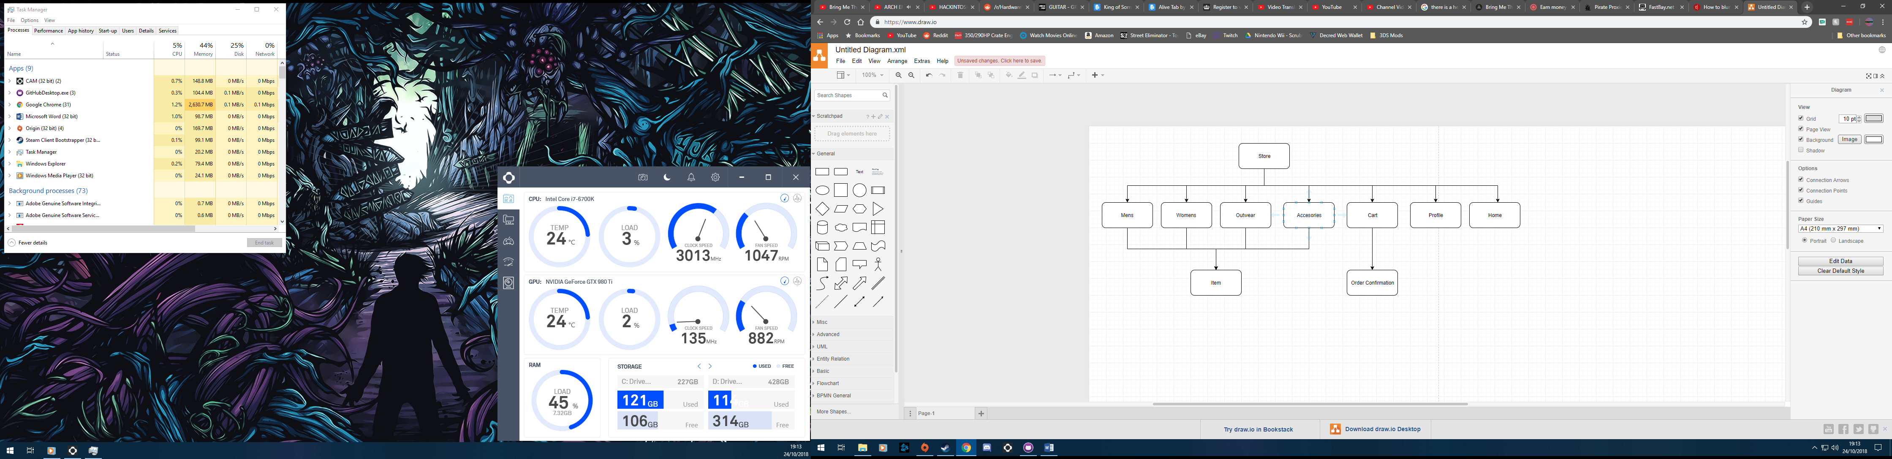

Profile

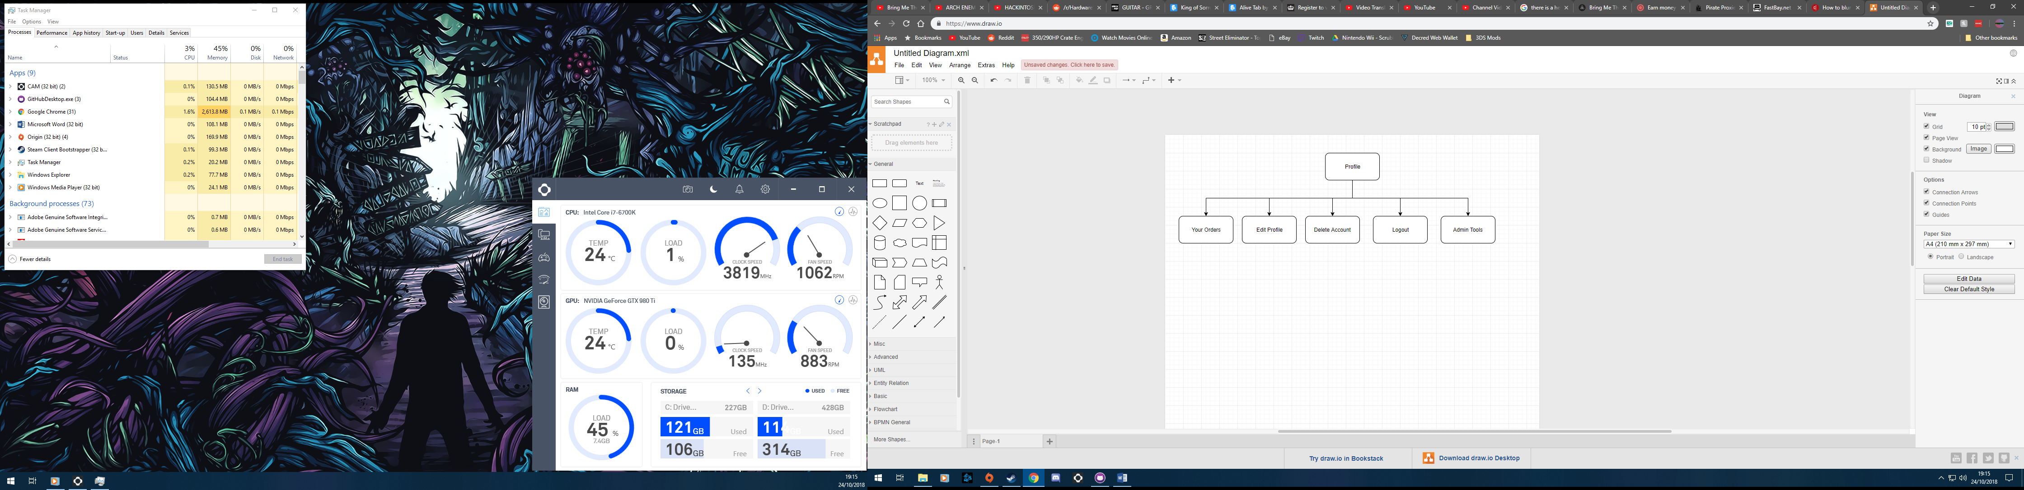

Admin Tools

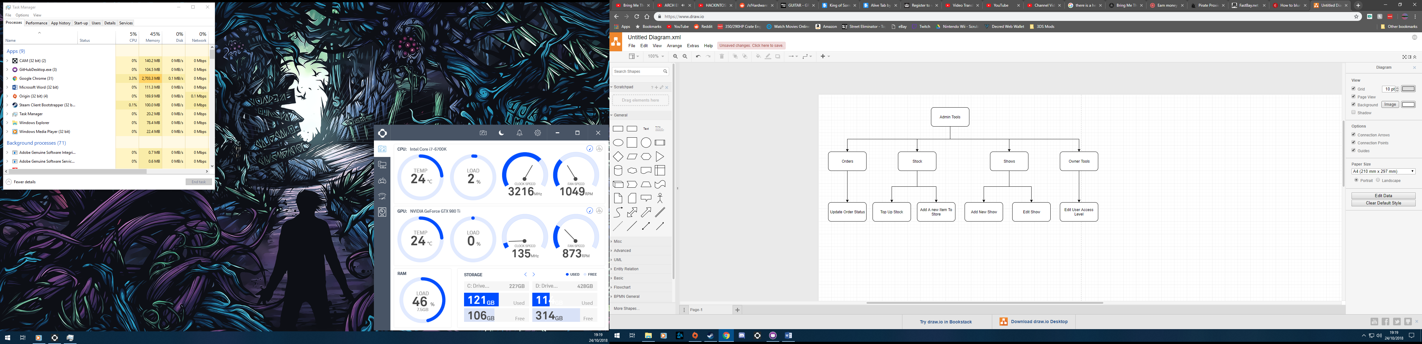

## Entity Relationship Diagram

Orders

Cart

User

Concerts

Email Notifications

Store

Stock

## Data Flow

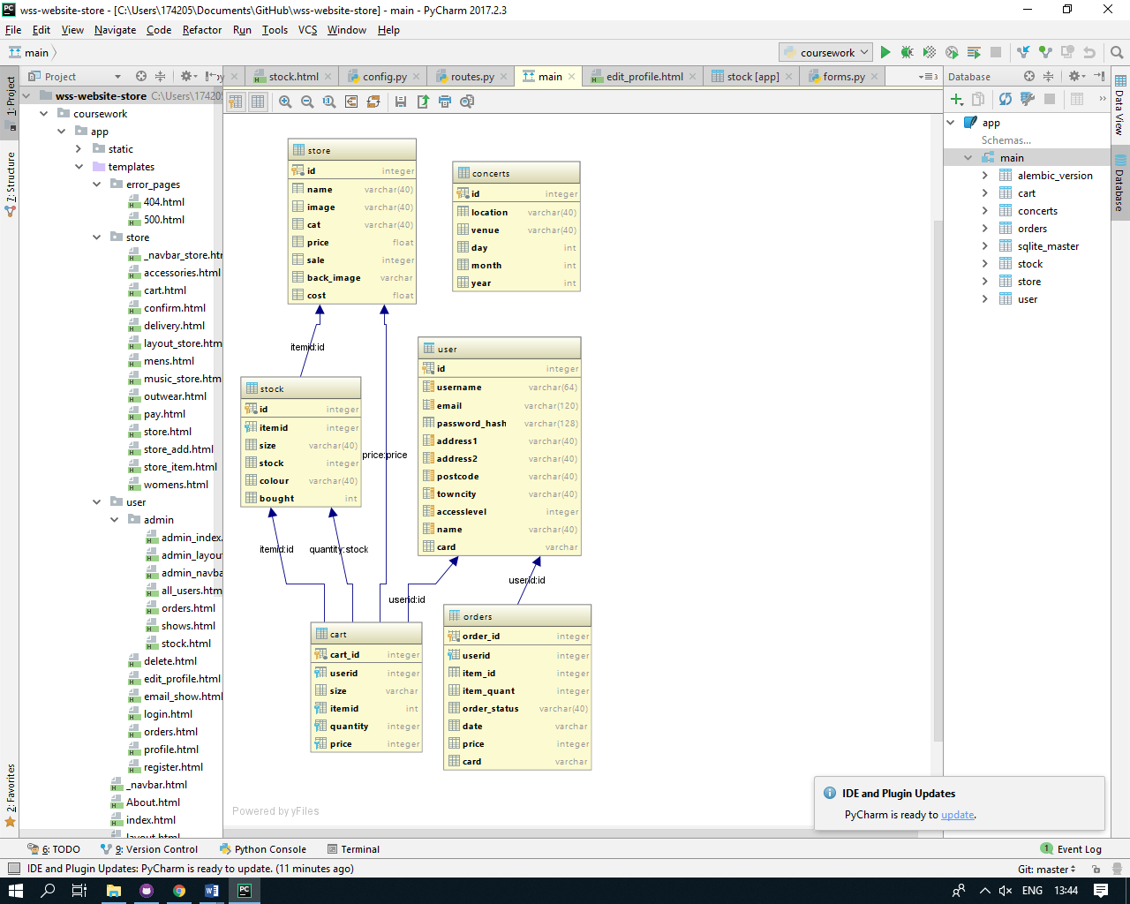

# Testing

## Test Strategy

My website and store will need to be tested toughly before it can be released to the public. This is to make sure that all users can a pleasant and easy explirence on the site. When testing, I will be looking for errors within my code and also the layout of the website. When found, the errors will be corrected. In my testing I will be checking for major and minor errors, but also the user experience. I will be using the following method for my testing:

I will start at the homepage as this is the first page that anyone will see if they enter the site. I will check that each of the links work on this page and that the page still flush on the user’s screen.

From here, I will go to the login/register page and show that a user can be created and then the user can login and logout easily. I will also show that a user cannot be logged in if the password is incorrect and that another account cannot be created with the same username or email. Registering an account can be used to save the user’s address, orders and set up email notifications of shows in their area. So the page must be easily read and edited as it is the most used part of the website. When logged in, the user can access their profile from the same place to login link was. From here the user can see all the data stored of them, see their orders. Edit their account, delete their account and log out. I will show that all of these functions work and that there are measures to stop accidental edits or deletion, by being password protected. Also, if the logged in user is of admin or owner status, then the admin tools page link will show up in the profile. Only a user will an access level of 2 or 3 can enter this page. I will prove that a non-admin cannot enter this or the owner page by trying to access it with a user with access level of 1, 2 and 3 and show what the differences are. On the admin section, an admin can see all the stock with the profit that that each item brings in, with the total profit of the website. They can view all shows, add a new show or edit an existing one. They can add stock to one item or add an entirely new item to store and finally they can view all the orders from all users and edit the status of them (dispatched and delivered). I will show all this working on test data that will be created through the testing of the other parts of the website such as ordering items from the store. In the user is of access level 3, when they enter the admin tools page, they will also see the owner tools sections, and here they can change the access level of each user to 1, 2 or 3. After this I will show how the shows that have already passed will be automatically deleted from the database. Even if the date is edited. And, how the user can set up email notifications for a specific location and if there is a show there, they will get an email.

Next, I will show the store and all the items in it. How each item has their own individual page, where it shows pictures, price and how much stock each size has. From here you can select what size and the quantity of item that the user wants to put into their cart. Then I will access my cart by clicking the cart icon on the navigation bar. This page shows all of the items in the specific user’s cart, the amount of each item and the total price of all the items. I will show how items can be removed or quantity lowered easily, by pressing the “remove” button. From here I will continue onto the confirming order page. The next page is the address confirmation, where the address entered on the profile will be brought forward but if it is not correct then there is a link to change it. After this, the next page is the payment page, where I will put some a card number, date and CVV, this is test data and money will not be taken. After this page is the order confirmation page, this is where the users’ cart, address and card will be shown so the user can make sure that it is correct. When the order is placed, I will show how the order has been added to the “Your Orders” page on the profile and how an email has been sent to the specific email that the user set in their account creation. After this, I will show how different users can only see their own orders and cart. This is to make sure that users do not get other users orders on their page and don’t get confused by it.

After this, I will logout of this account and login to an owner account. From here, I will show that when you are an admin or an owner, there is now a new link to the admin tools in the profile. I will then go to the admin page but straight after logout of my account and back into the test account. I will then show that even if a user knows the url, if they do not have the access level, then they cannot enter the admin or owner page and it will just return a 404 error. Now I will log back into the admin account and back into the “admin tools” page. On the main admin page, it shows the entire stock and how much profit each item makes. There is also a pie chart that shows the website’s costs and profits. There is also an additional navbar for the admin tools section, and if the user has an access level of 3, will also get the owner tools here. I will then show this difference by showing that the logged in account (“Richard”) has an access level of 3, and then I will log into an admin account and when I go onto the admin tools, the “owner tools” section will not be there. In the “Stock” section of the admin tools, it shows the user all the stock and the information on the items, for example the amount bought and price. From this page, I will show that an admin can top up the stock of a specific item and add a new item to the store entirely. After this is will show the orders page, this page shows all of the orders of all of the users. Its also shows the status of their order, however if the status of the order is delivered, the order is not shown in the table. Also, from this page, I will show that an admin can change the status of an order, when it is needed, this would be when the order has been dispatched and confirmed as delivered. When an order status is changed, the users who created the order will receive an email of the status change pf their order, I will show this happening for both “dispatched” and “delivered”. The final part of the admin page is the shows tools. This is where the admin can see all the upcoming shows. They can also create and edit the show easily. I will show the creation and editing of a show and in doing so I will created one that has a date that already past, this is because when someone enter the “shows” page, the website works out the current date and compares it to the date of the show and if the show has a date that has already been, it will delete that show from the database, so it will not be displayed.

Next, I will show the owner tools page, here the owner (someone of access level of 3), can see all the users on the database, along with their full name and their email. Here an owner can change the access level of a specific user to either 1 (regular user), 2 (admin) or 3 (owner). And I can show how changing this leads users to be able to access the admin and owner tools.

I will show this by logging back out of the owner account and back into the test account. Now on the profile page, there will be the admin tools button. But when I go into it, the owner tools section is missing, this is because to access owner tools an access level of 3 is needed, which this account doesn’t have.

After I have shown this, I will show how an order status can be changed by selecting the order id and changing the status to “Dispatched”. When this happens, the website also sends an email to the user telling them that their order has been dispatched. I will show this happening by using a test account on Gmail. The same also applies to when an order is changed to “Delivered”, however this order now disappears from the orders table, this is because the “delivered” orders are all filtered out, so it does not clutter up the page. Next, I will show the stock page, this page shows all the stock and necessary information on it. From this page and admin is able to add stock to an existing item or create a new item entirely. I will show both working.

Following this, I will show how the show email notifications work. So, a user will go to the “shows” page and then from here press the link to “Set Up Email Notification”. From here the user types in the location for which they would like to receive emails for. The email used is pulled directly from the User Database. Now when I go back into the admin tools page and the shows section when I created a show or edit an existing one, It scan the email notifications database and if there is a match, it will send and email to the user, with the location in the email, in case they have set up multiple email notifications.

Finally, I will show how other others are not able to access any data on any other user. I will show this by showing that a user can only ever access their own profile, even if they type in other users’ url. Also, I will show how the different users’ cart stay different, so peoples saved items don’t cross into other users’ cart. Also, during this I will show that a user’s cart is saved so even if they don’t enter the site for a year, along as the item still exists, it will still be in their cart.

## Testing video

<https://youtu.be/DLxIps2yyZY>

## Test Table

|  |  |  |  |  |  |  |
| --- | --- | --- | --- | --- | --- | --- |
| Test No. | Purpose of the test | Test Data | Expected Outcome | Actual Outcome | Changes Needed | Video Timestamp |
| 1 | Create account. Check if for requirements work. | U: test  E: wsstestdat  P: Test | Account Created. And form works | Account Created and form works | None | 01:04 |
| 2 | Login | U: test  P: test | Logs into account | Logs into account | None | 01:10 |
| 3 | Profile works and all link in profile | None | All open | All open | None | 01:17 |
| 4 | Access profile without being logged in | /profile/test | Login error. Redirects to login page | Login error. Redirects to login page | None | 01:49 |
| 5 | Access test profile while logged in to another account | /profile/test | Loads profile for logged in user | Loads profile for logged in user | None | 02:02 |
| 6 | Incorrect Username | U: test1 | Will not login | Will not login | None | 02:14 |
| 7 | Incorrect Password | P:test1 | Will not login | Will not login | None | 02:17 |
| 8 | Edit Profile | Name: Rich | Changes made to database | “CSRF Token Missing” Error | Find/create token | 02:39 |
| 9 | Showing all links on index navbar work | None | All pages open | All pages open | None | 02:50 |
| 10 | Show all links work in the store | None | All pages open | All pages open | None | 03:17 |
| 11 | Each item has a specific page | None | Item Page Open | Item Page opens | None | 03:31 |
| 12 | Add item to cart | M 3 | Items adds to cart | Items adds to cart | None | 03:36 |
| 13 | Remove 1 items from cart | None | Quantity goes to 2 | Quantity goes to 2 | None | 03:42 |
| 14 | Add second item to cart | XL 1 | Adds item to cart | Adds item to cart | None | 03:49 |
| 15 | Remove item from cart | None | Removes item | Removes item | None | 05:54 |
| 16 | Checkout pulls address from profile | None | Address is present | Address is present | None | 04:02 |
| 17 | Card form can only take correct amount of numbers | 17 characters card number | Doesn’t continue card must be 16 characters | Doesn’t continue card must be 16 characters | None | 04:31 |
| 18 | Confirmation shows address, cart and last 4 digits of card | None | Address, cart and card number is present | Address, cart and card number is present | None | 04:35 |
| 19 | Order placed | None | Order is placed | Order is placed | None | 04:54 |
| 20 | Email is sent | None | Email is present | Email is present | None | 05:06 |
| 21 | Order is in “Your Orders” | None | Order is present | Order is Present | None | 05:22 |
| 22 | Admin tools pages open and google charts work | None | Pages open and google charts work | Pages open and google chart work | None | 05:59 |
| 23 | Update Order Status | 14 “Dispatched” | Order updates | Order Updates | None | 07:20 |
| 24 | Email is sent to user | None | Email is received | Email is received | None | 07:27 |
| 25 | Update order status | 14 “Delivered” | Order updates and disappears from table” | Order updates and disappears from table” | None | 07:35 |
| 26 | Change Access Level | Test 2 [password] | Access level changes | Access level changes | None | 08:16 |
| 27 | Show admin tools shows up in test profile | None | Admin tools link is present | Admin tools link is present | None | 08:37 |
| 28 | Show that owner tool sis not here for access level 2 | None | Owner tools is not present | Owner tools is not present | None | 08:37 |
| 29 | Set up email notifications | London | Set up works | Set up works | None | 08:46 |
| 30 | Add a show | London 18 11 2021 gfvsfg | Show is added | Show is added | None | 09:15 |
| 31 | Email is sent out | None | Email is received | Email is not received | Check the email is correct and is sent to the correct person as It works on my other account | 09:25 |
| 32 | Show is in Shows page | None | New show is present | New show is present | None | 09:31 |
| 33 | Show that if a show is in the past, it will be deleted | Afa 1 1 2018 fvuhsf | Show is in table but then not in shows page because it is deleted | Show is in table but then not in shows page because it is deleted | None | 09:48 |
| 34 | Try and get into admin tools when not logged in | /admin | Returns 404 error | Returns 404 error “page not found” | None | 10:30 |
| 35 | Try and get into admin tools as logged in user with access level of 1 | /admin | Returns 404 error | Returns 404 error | None | 11:30 |
| 36 | Orders are different between account | 2 accounts | Order pages are different | Order pages are different | None | 11:57 |
| 37 | Cart pages are different between users | 2 accounts | Carts are different between users | Carts are different between users | None | 12:17 |

# Evaluation

|  |  |  |  |
| --- | --- | --- | --- |
| Objective | Met | Comment | Test Reference |
| Have a functioning profile system | Yes | Each user has a profile which shows the data stored on them and gives them a link to their orders. Each user is also able to edit or delete their account from here | 3 |
| Be able to update the profile by the user | No | There is a CSRF Token Missing” error which is messing with the form. However, this has been met before | 8 |
| Have a store that can be used by the user to buy merchandise | Yes |  | 9-20 |
| Have the store pull the address from the user’s profile but ask whether it is correct. | Yes | The user’s address is displayed and if it is not correct, there is a link that allows the user to change it. | 16 |
| Have a most popular page on the store that is automatically updated with the items that have been bought the most | No | This could be implemented as the algorithm is in use on the admin index page. However, it is not used as there is not enough stock to warrant it’s use. | 10 |
| Have an easily updatable shows page, that’s takes of a show when it is in the past | Yes | Whenever, someone enters the shows page, the website gets the current date and compares it to date of the show and if the show is before then it is deleted from the database | 33 |
| Have the shows page be updated by an admin | Yes | A show can be created or edited easily by an admin in the admin tools section of their profile | 30 |
| Have tweets from their official twitter integrated into the home page | Yes | The band official twitter feed is on the right band side of the homepage | 0 (first second in the video is the homepage, and this page is shown multiple times throughout the video) |
| Be able to put items from different categories into the cart | Yes | This can be done very easily and was never a problem to begin with | 14 |
| Have a clean that is easy to understand so people can easily navigate around the website | Yes | There are navigation bars on every page that has the necessary links the move around dedicated area | The whole video shows this |
| Have an admin page that can be used to manage the shows page, the stock and orders | Yes | In the admin tools, an admin can update all of these with new shows, edit shows, top up stock, add a new item to the store and update orders | 22 |
| Remember the cart for a specific user when the user closes the website or logs out | Yes | The cart is saved in a database so unless the user removes an item, it will stay there | 37 |
| Let the user delete their account | Yes | They just have to confirm their password and click submit and their account is deleted from the database | Is not shown in the video but is easy done by a db.session.remove(user) |
| Have the website show all the necessary information on the band | Yes | There is an about page which houses all of this information | 9 |
| Have a page to view previous order with the amount spent and items bought | Yes | This is the “your orders” page in the profile section. This displays all previous order, the cost and the status amongst other things | 21 |
| Have a page that can show the status of the ongoing orders | Yes | This is also the “Your Orders” page in the profile section | 21 |
| Have different level of access for different users | Yes | Each user has an access level, 1: regular user, 2: admin and 3: owner | 26 |
| Have a page where an owner can change the permissions of the users | Yes | This is the owner part of the admin tools. Where an owner can select a user and then change their access level, but they also have to enter their password | 26 |
| Let an admin add shows or edit shows | Yes | This is done in the admin tool section and works for both editing and creating shows | 30 |
| Let an admin add a new item to the store or add stock to an existing item | Yes | An admin can easily create a new item using a form or add stock to existing item with a drop-down selector for the item and then they enter an amount to add to it | This is not shown in the video, but the process is shown multiple times, it is just adding something to a database or increasing a number in a database |
| Allow an admin to put an item on sale | No | I didn’t include the sale to work into the price, so this would have no purpose | N/A |
| Allow admins to see all the orders that aren’t delivered and change their status | Yes | An admin can see all the orders and be selecting an order using a drop-down can change the status of it | 23 |
| Have email notifications for shows that are coming to a specific area | Yes | This worked on my person al account but not on my test data | 31 |